Programming with Haiku

Lesson 26

Written by DarkWyrm

All material © 2011 DarkWyrm

Resources: In-Program Data Storage
Resources are a way of bundling data related to your program into the final executable itself. They are stored in a structured format which makes it possible to load everything all at once or just load only the data you need.
Before we dive headlong into the details of manipulating program resources, there are first some caveats which must be mentioned. First, resources are stored in only two kinds of files: resource files and executables – text documents and other regular files cannot have resources. Second, any data placed into a program's resources increases the overall size of the program. Each time your program is loaded, the entire file must be brought into memory, so large chunks of data will increase load times – keep your large data in separate files.
During development resources are stored in their own file and added to your program near the end of the build process. Resource files come in two flavors: text and binary. Binary resource files have the .rsrc extension. Text resource files have the .rdef extension and must be compiled before they can be added to an executable. If you create a new .rdef file from within the Paladin development environment, it creates a file containing this template:

/*--------------------------------------------------------------------
Change the value in quotes to match the signature passed
to the BApplication constructor by your program.
--------------------------------------------------------------------*/
resource app_signature "application/x-vnd.me-MyAppSignature";

/*--------------------------------------------------------------------
Value for app flags can be B_SINGLE_LAUNCH, B_MULTIPLE_LAUNCH, or
B_EXCLUSIVE_LAUNCH.

Additionally, you may also add the B_BACKGROUND_APP or
B_ARGV_ONLY flags via a pipe symbol, such as the following:
B_SINGLE_LAUNCH | B_BACKGROUND_APP

B_SINGLE_LAUNCH is the normal OS behavior
--------------------------------------------------------------------*/
resource app_flags B_SINGLE_LAUNCH;

/*--------------------------------------------------------------------
Set the version information about your app here.
The variety can be set to one of the following values
B_APPV_DEVELOPMENT,
B_APPV_ALPHA,
B_APPV_BETA,
B_APPV_GAMMA,
B_APPV_GOLDEN_MASTER,
B_APPV_FINAL
--------------------------------------------------------------------*/
resource app_version {
major = 0,
middle = 0,
minor = 1,

variety = B_APPV_DEVELOPMENT,
internal = 0,

short_info = "A short app description",
long_info = "A longer app description"
};

resource large_icon array {
$"1C1C1C1C1C1C1C1C1C1C1C1C1C1C1C1C1C1C1C1C1C1C1C1C1C1C1C1C1C1C1C1C"
$"1C1C1C1C1C1C1C1C1C1C1C1C1C1C1C1C1C1C1C1C1C1C1C1C1C1C1C1C1C1C1C1C"
$"1C1C1C1C1C1C1C1C1C1C1C1C1C1C1C1C1C1C1C1C1C1C1C1C1C1C1C1C1C1C1C1C"
$"1C1C1C1C1C1C1C1C1C1C1C1C1C1C1C1C1C1C1C1C1C1C1C1C1C1C1C1C1C1C1C1C"
$"1C1C1C1C1C1C1C1C1C1C1C1C1C1C1C1C1C1C1C1C1C1C1C1C1C1C1C1C1C1C1C1C"
$"1C1C1C1C1C1C1C1C1C1C1C1C1C1C1C1C1C1C1C1C1C1C1C1C1C1C1C1C1C1C1C1C"
$"1C1C1C1C1C1C1C1C1C1C1C1C1C1C1C1C1C1C1C1C1C1C1C1C1C1C1C1C1C1C1C1C"
$"1C1C1C1C1C1C1C1C1C1C1C1C1C1C1C1C1C1C1C1C1C1C1C1C1C1C1C1C1C1C1C1C"
$"1C1C1C1C1C1C1C1C1C1C1C1C1C1C1C1C1C1C1C1C1C1C1C1C1C1C1C1C1C1C1C1C"
$"1C1C1C1C1C1C1C1C1C1C1C1C1C1C1C1C1C1C1C1C1C1C1C1C1C1C1C1C1C1C1C1C"
$"1C1C1C1C1C1C1C1C1C1C1C1C1C1C1C1C1C1C1C1C1C1C1C1C1C1C1C1C1C1C1C1C"
$"1C1C1C1C1C1C1C1C1C1C1C1C1C1C1C1C1C1C1C1C1C1C1C1C1C1C1C1C1C1C1C1C"
$"1C1C1C1C1C1C1C1C1C1C1C1C1C1C1C1C1C1C1C1C1C1C1C1C1C1C1C1C1C1C1C1C"
$"1C1C1C1C1C1C1C1C1C1C1C1C1C1C1C1C1C1C1C1C1C1C1C1C1C1C1C1C1C1C1C1C"
$"1C1C1C1C1C1C1C1C1C1C1C1C1C1C1C1C1C1C1C1C1C1C1C1C1C1C1C1C1C1C1C1C"
$"1C1C1C1C1C1C1C1C1C1C1C1C1C1C1C1C1C1C1C1C1C1C1C1C1C1C1C1C1C1C1C1C"
$"1C1C1C1C1C1C1C1C1C1C1C1C1C1C1C1C1C1C1C1C1C1C1C1C1C1C1C1C1C1C1C1C"
$"1C1C1C1C1C1C1C1C1C1C1C1C1C1C1C1C1C1C1C1C1C1C1C1C1C1C1C1C1C1C1C1C"
$"1C1C1C1C1C1C1C1C1C1C1C1C1C1C1C1C1C1C1C1C1C1C1C1C1C1C1C1C1C1C1C1C"
$"1C1C1C1C1C1C1C1C1C1C1C1C1C1C1C1C1C1C1C1C1C1C1C1C1C1C1C1C1C1C1C1C"
$"1C1C1C1C1C1C1C1C1C1C1C1C1C1C1C1C1C1C1C1C1C1C1C1C1C1C1C1C1C1C1C1C"
$"1C1C1C1C1C1C1C1C1C1C1C1C1C1C1C1C1C1C1C1C1C1C1C1C1C1C1C1C1C1C1C1C"
$"1C1C1C1C1C1C1C1C1C1C1C1C1C1C1C1C1C1C1C1C1C1C1C1C1C1C1C1C1C1C1C1C"
$"1C1C1C1C1C1C1C1C1C1C1C1C1C1C1C1C1C1C1C1C1C1C1C1C1C1C1C1C1C1C1C1C"
$"1C1C1C1C1C1C1C1C1C1C1C1C1C1C1C1C1C1C1C1C1C1C1C1C1C1C1C1C1C1C1C1C"
$"1C1C1C1C1C1C1C1C1C1C1C1C1C1C1C1C1C1C1C1C1C1C1C1C1C1C1C1C1C1C1C1C"
$"1C1C1C1C1C1C1C1C1C1C1C1C1C1C1C1C1C1C1C1C1C1C1C1C1C1C1C1C1C1C1C1C"
$"1C1C1C1C1C1C1C1C1C1C1C1C1C1C1C1C1C1C1C1C1C1C1C1C1C1C1C1C1C1C1C1C"
$"1C1C1C1C1C1C1C1C1C1C1C1C1C1C1C1C1C1C1C1C1C1C1C1C1C1C1C1C1C1C1C1C"
$"1C1C1C1C1C1C1C1C1C1C1C1C1C1C1C1C1C1C1C1C1C1C1C1C1C1C1C1C1C1C1C1C"
$"1C1C1C1C1C1C1C1C1C1C1C1C1C1C1C1C1C1C1C1C1C1C1C1C1C1C1C1C1C1C1C1C"
$"1C1C1C1C1C1C1C1C1C1C1C1C1C1C1C1C1C1C1C1C1C1C1C1C1C1C1C1C1C1C1C1C"
};

resource mini_icon array {
$"1C1C1C1C1C1C1C1C1C1C1C1C1C1C1C1C"
$"1C1C1C1C1C1C1C1C1C1C1C1C1C1C1C1C"
$"1C1C1C1C1C1C1C1C1C1C1C1C1C1C1C1C"
$"1C1C1C1C1C1C1C1C1C1C1C1C1C1C1C1C"
$"1C1C1C1C1C1C1C1C1C1C1C1C1C1C1C1C"
$"1C1C1C1C1C1C1C1C1C1C1C1C1C1C1C1C"
$"1C1C1C1C1C1C1C1C1C1C1C1C1C1C1C1C"
$"1C1C1C1C1C1C1C1C1C1C1C1C1C1C1C1C"
$"1C1C1C1C1C1C1C1C1C1C1C1C1C1C1C1C"
$"1C1C1C1C1C1C1C1C1C1C1C1C1C1C1C1C"
$"1C1C1C1C1C1C1C1C1C1C1C1C1C1C1C1C"
$"1C1C1C1C1C1C1C1C1C1C1C1C1C1C1C1C"
$"1C1C1C1C1C1C1C1C1C1C1C1C1C1C1C1C"
$"1C1C1C1C1C1C1C1C1C1C1C1C1C1C1C1C"
$"1C1C1C1C1C1C1C1C1C1C1C1C1C1C1C1C"
$"1C1C1C1C1C1C1C1C1C1C1C1C1C1C1C1C"
};

As you can see from the template, resources are the storage medium for some of the information about your program, such as its version and its icons. The application signature should match the one used in your program's BApplication constructor. If it doesn't, an annoying warning about a signature mismatch is printed to the Terminal every time your program executes. The app_flags field will usually be B_SINGLE_LAUNCH or B_MULTIPLE_LAUNCH, depending on what kind of application you are building. If you are writing some sort of background daemon or service, you will also need the B_BACKGROUND_APP flag. app_version information is utilized primarily by Tracker when the user chooses the Get Info command on your program.
Although it is possible to create an icon strictly using pixel definitions like the above, it is not recommended. These icon definitions are for the old BeOS standard icons which can use only 256 colors and have a fixed size of 32 or 16 pixels. The preferred method is to create a vector icon using Icon-O-Matic and export the information to a resource file.

Resource Tools
Speaking of tools, Haiku has several which manipulate resources. While some are more generalized than others, no single tool handles all of the possible resource types and some are, by far, easier to use for certain tasks.

FileTypes
Better known as a Preferences application, FileTypes is also a Tracker add-on. When invoked as such on a program or resource file, it opens in a different mode which is intended to edit standard program resources, such as supported file types, version information, and other attributes discussed above. Given a choice, it is the best option for these general-purpose resources. | 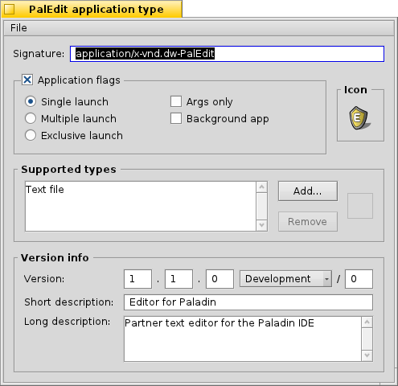

QuickRes
Perhaps the oldest of the resource editing tools, QuickRes hails from the heyday of BeOS. At the moment, it is the best available resource editor and supports a wide variety of different resource types. It does carry one significant drawback, however: it is closed source and cannot be run on non-hybrid builds of Haiku based on the GCC4 compiler. As old as it is, it also cannot edit Haiku vector icons. It can be obtained online at the Haikuware.com software website. | 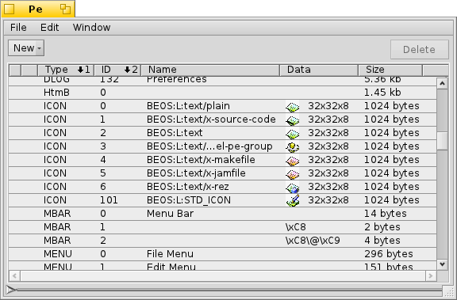

ResEdit
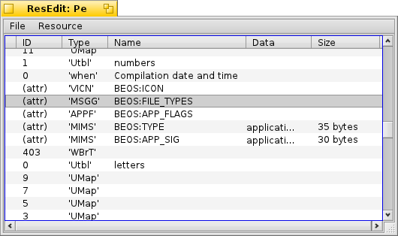 | By contrast, ResEdit is the youngest resource editor of the bunch. It is an open source editor included in the Haiku source tree which is styled after QuickRes. As of this writing, it is not yet feature-complete, but it does allow you to add and remove resources from resource files.

Icon-O-Matic
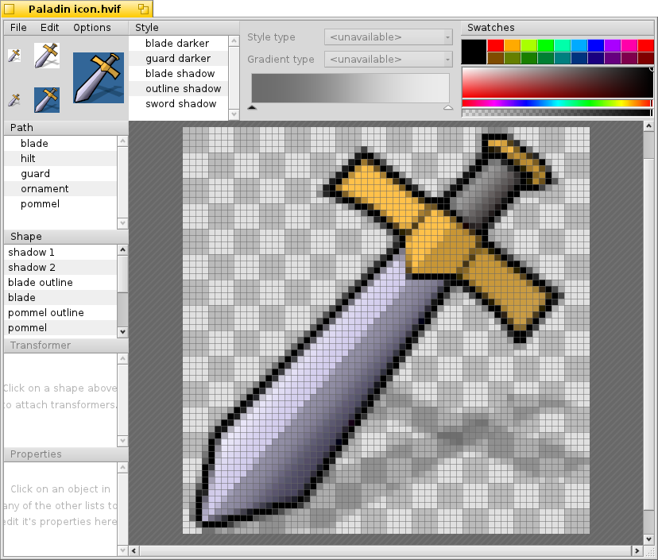 | Icon-O-Matic was written to edit Haiku's HVIF vector icon format. The icons it creates can look good and are quite small, but its workflow is not immediately obvious. There are videos available on YouTube and information in the Haiku documentation which are quite helpful for learning how to create beautiful icons with this tool. It is included with Haiku. Icon-O-Matic has the capability to export icons to different formats, including bitmap images (PNG, etc.) as well as the HVIF format and even .rdef files.

xres
xres is one of two shell commands for working with resources. It is complicated, but it is the only way to manipulate resource files from the command line. It is also how many build systems merge .rsrc files into applications after compiling and linking.

rc
Short for resource compiler, this shell command converts between the text-based .rdef files and the binary .rsrc files.

Using Resources
Once we have placed information into a program's resources, it is not difficult to access them at runtime. Depending on what kind of information we need, there can even be more than one way to get it. Two of the methods provided by the BTranslationUtils class can get images stored in resources, and for anything else, the BResources class is the way to go.
Storing icons or other small images used by your program into its resources is a very common trick to ensure that the user hasn't replaced the New Folder icon with the recipe for his aunt's famous chocolate cream pie. There are two versions of BTranslationUtils::GetBitmap() which come in especially handy this way:

static BBitmap * GetBitmap(uint32 type, int32 id,
BTranslatorRoster *roster = NULL);
static BBitmap * GetBitmap(uint32 type, const char *name,
BTranslatorRoster *roster = NULL);

Common type codes are defined in TranslatorFormats.h and TypeConstants.h. While it doesn't really matter what ID number a resource has, it does have to be unique to other resources of its type. The ID version of GetBitmap() is useful if you are looping through a series of images, but the string version is good if you want to load a particular image – it's often easier to remember a name than an arbitrary number.
The BResources class is a generic interface to your program's resources. Although it is used to write resource editors like ResEdit, it is more often used to access resources at runtime. You can call BApplication::GetResources() to get a pointer to a BResources instance which points to your program's resources, but keep in mind that you should only read resources while a program is running, not write them.
Let's look at some code which prints the resource entries of a given file.

#include <Resources.h>
#include <String.h>
#include <stdio.h>

BString
Int32Code2String(const int32 &code)
{
// Used to translate 32-bit integers into the 4-character constants
// often used for formats and BMessage what fields.
BString out("'");
out << (char)((code & 0xFF000000) >> 24)
<< (char)((code & 0x00FF0000) >> 16)
<< (char)((code & 0x0000FF00) >> 8)
<< (char)((code & 0x000000FF))
<< "'";
return out;
}

void
PrintResources(const char *path)
{
// This particular version of the BResources constructor is not found
// in BeOS or Zeta, but it can easily be replaced by another version
// which takes a BFile object instead.
BResources res(path);
if (res.InitCheck() != B_OK)
return;

// Reading resources from a file follows yet another usage pattern
// occasionally found in the API: giving a function an index until
// the read function fails. In this case, we create an index
// variable, attempt to read the resource at that index, and if we
// succeed, do what we want with the information obtained, increment
// the index, and repeat until the call fails. This usage pattern is
// most commonly done with reading entry_refs from a BMessage.
int32 resIndex = 0;
type_code resType;
int32 resID;
const char *resName;
size_t resSize;

printf("Resources in file %s:\n", path);
bool resourceFound = false;
while (res.GetResourceInfo(resIndex, &resType, &resID, &resName,
&resSize))
{
resourceFound = true;
BString line;
line << "\t" << Int32Code2String(resType) << "\t" << resID;
if (resName)
line << "\t" << resName;

line << "\t" << resSize << " bytes";
printf("%s\n", line.String());
resIndex++;
}
if (!resourceFound)
printf("\tNone\n");
}

int
main(int argc, char **argv)
{
if (argc == 2)
PrintResources(argv[1]);
else
printf("Usage: %s <filename>\n", argv[0]);

return 0;
}

The only thing left is what to do if we want to load resources and use them. It's dead simple: call LoadResource(). Here are the declarations for the call:

const void *LoadResource(type_code type, int32 id, size_t *outSize);
const void *LoadResource(type_code type, const char *name,
size_t *outSize);

LoadResource() returns a pointer to whatever data is held in the resource you specify. If there is a problem, it returns NULL. Of course, the pointer only remains valid for as long as the BResources instance remains unchanged. It's almost easy enough to be absurd.

Concluding Thoughts
Every Haiku developer should know what resources are and how to use them, if for no other reason than their flexibility and utility. I'm sure that in your coding exploits you'll find them quite handy. Don't be afraid to use your own resource type codes for your own purposes, either.

